**MIDDLETON CHENEY FOOTBALL CLUB**

**ANNUAL GENERAL MEETING**

**1995**

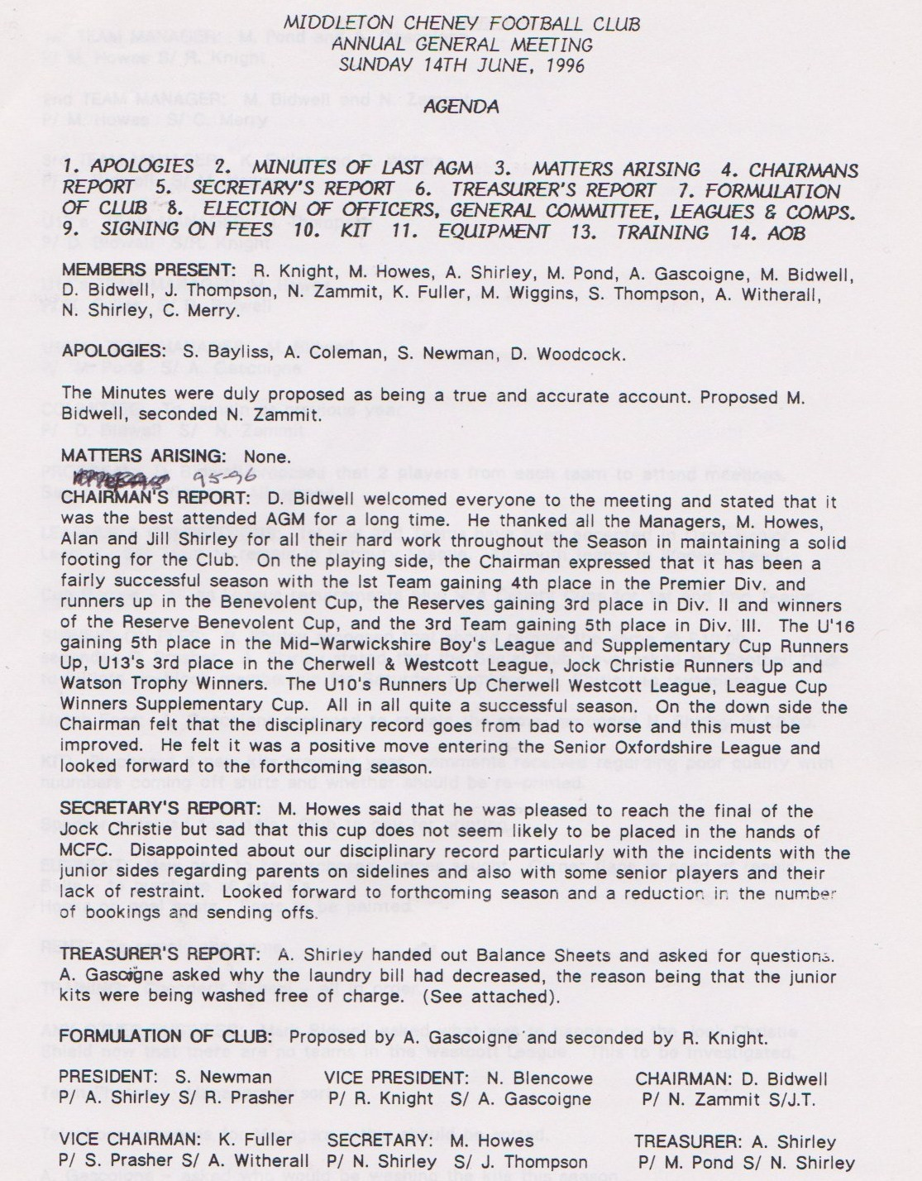

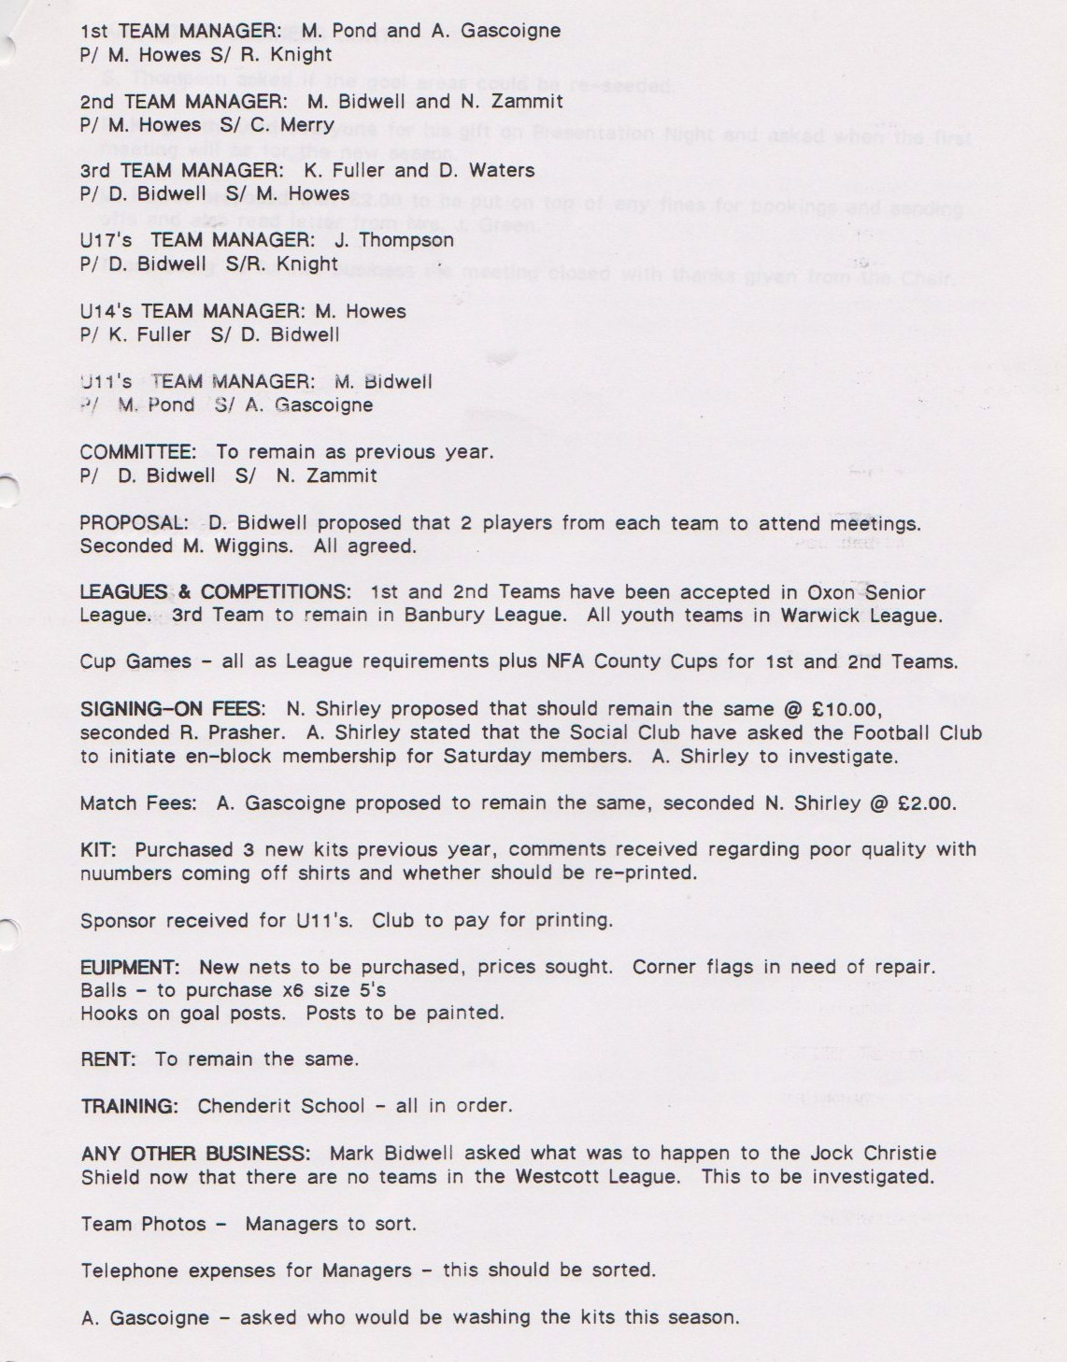

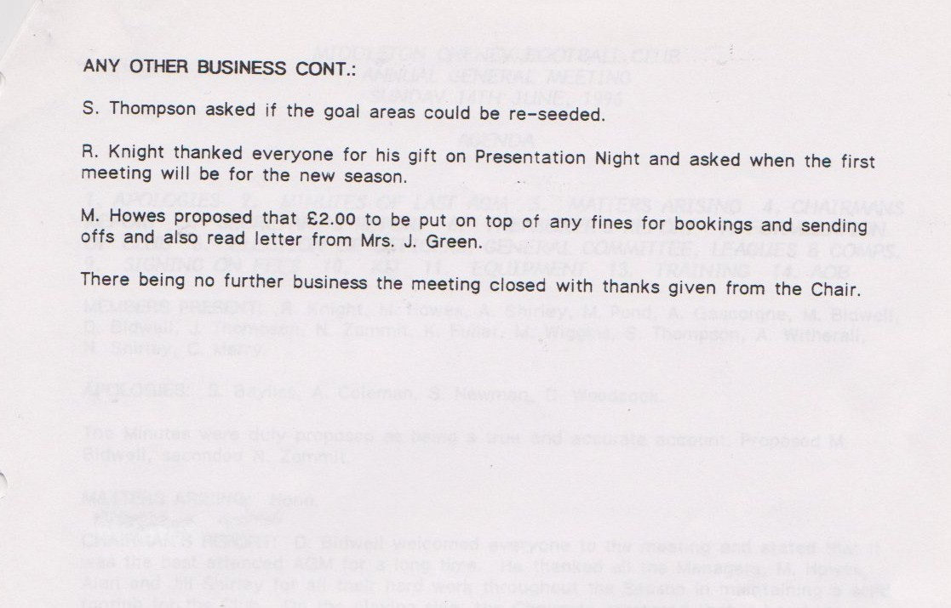

**General Committee Meeting**

**December 2nd 1995**

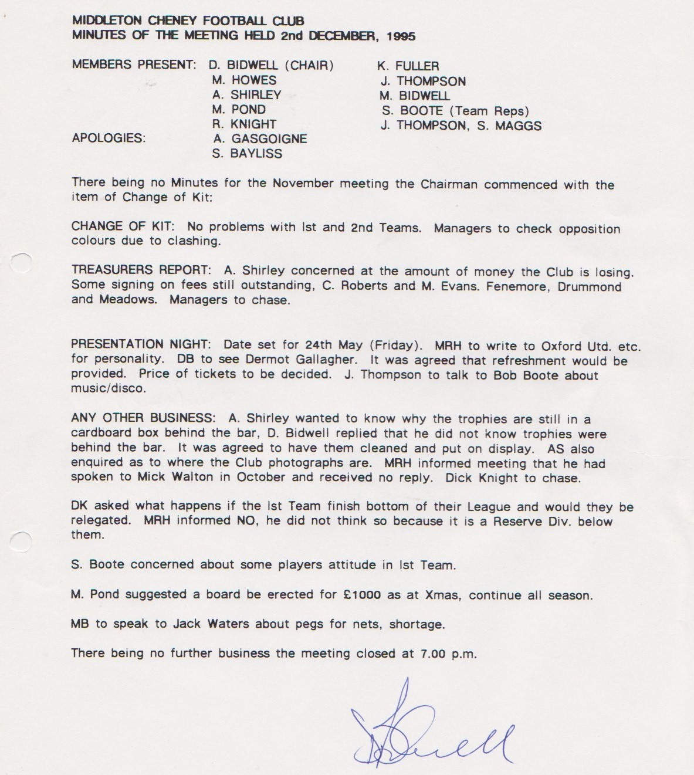

**General Committee Meeting**

**January 13th 1996**

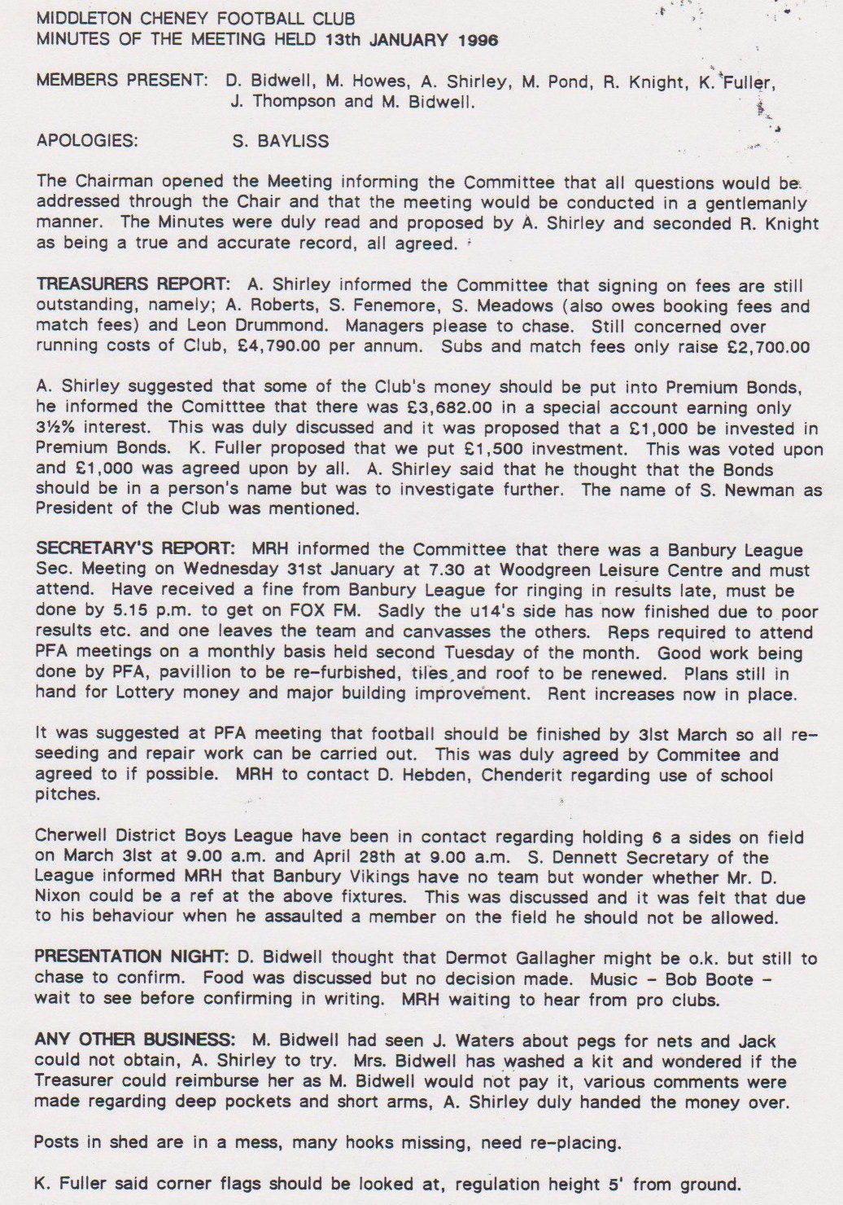

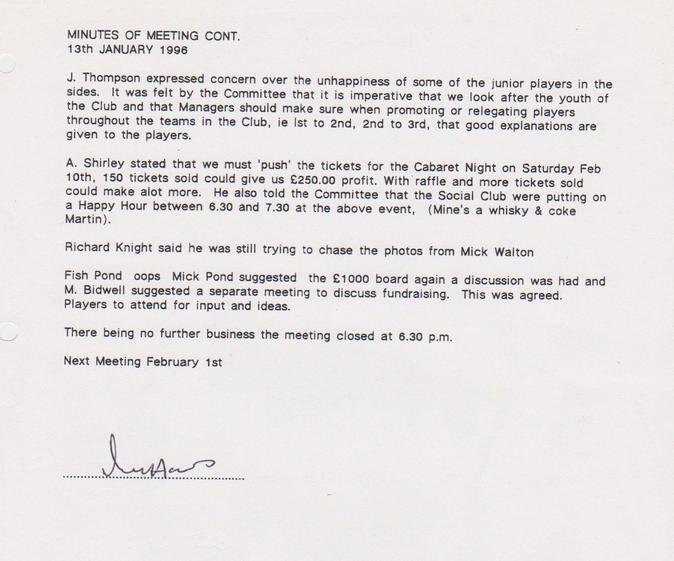

**General Committee Meeting**

**February 3rd 1996**

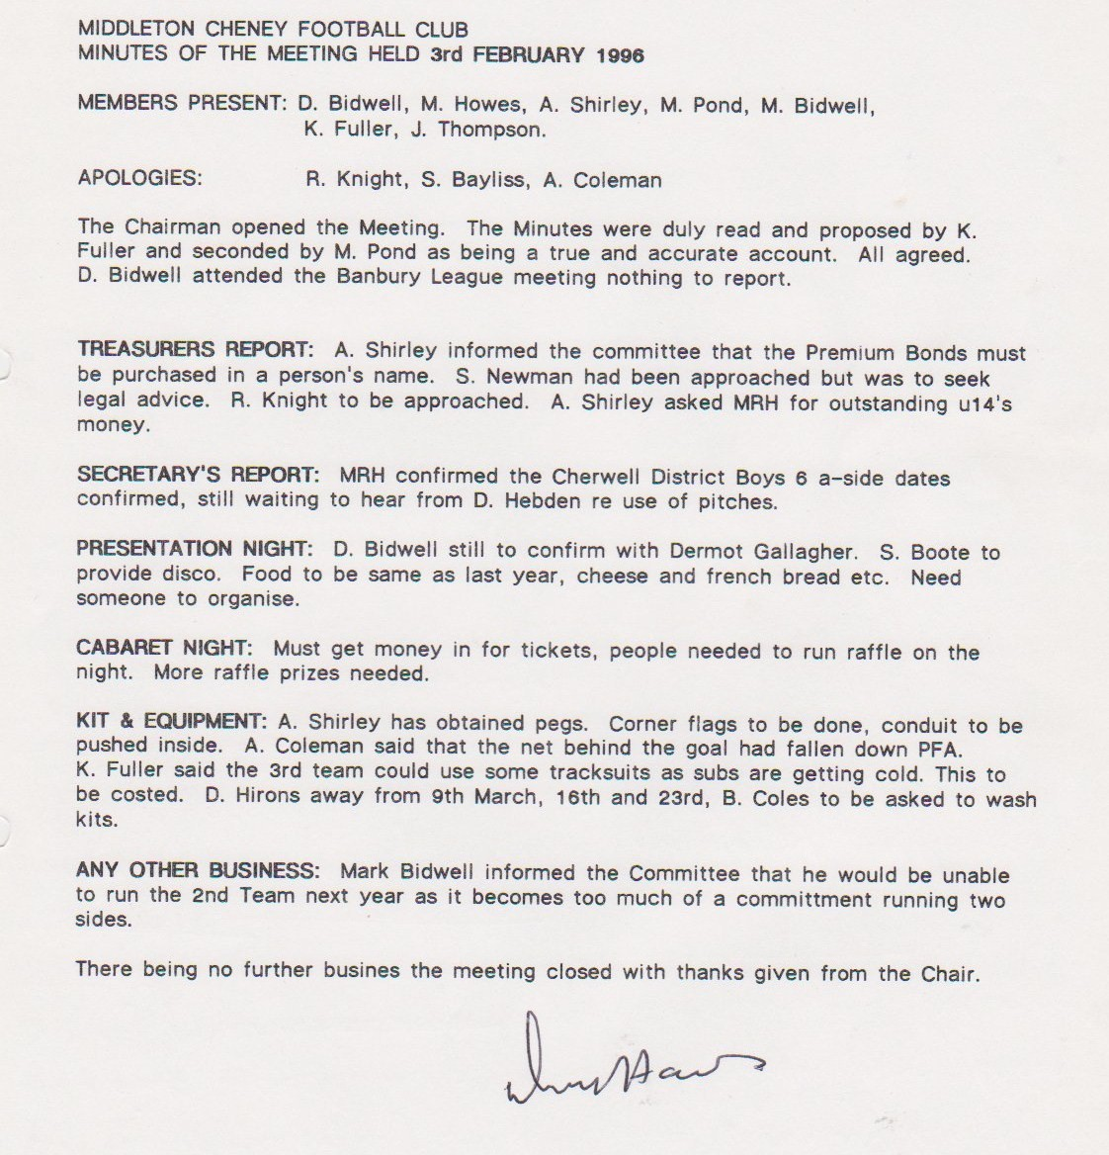

**General Committee Meeting**

**March 2nd 1996**

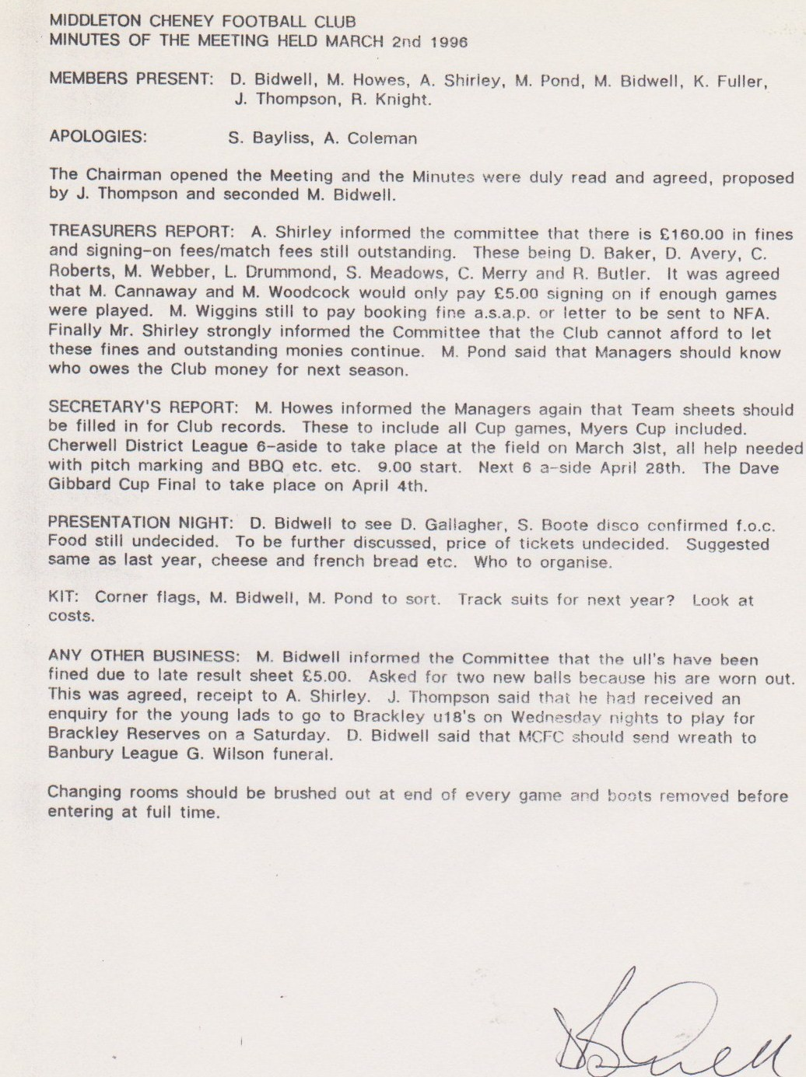

**General Committee Meeting**

**April 6th 1996**

